Winter Recipes South Africa

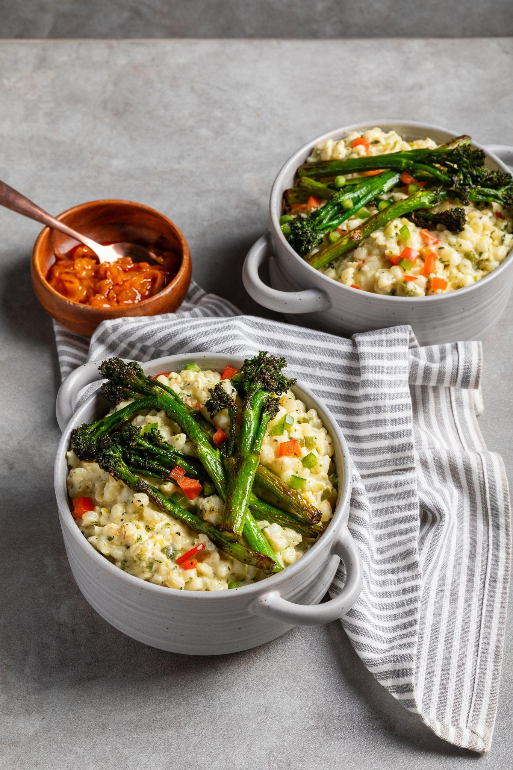
Roasted Tenderstem® with Creamy Herbed Samp

Ingredients
1 packet Tenderstem® broccoli
15g butter
Salt and black pepper, to taste
2 cups samp (soaked overnight and rinsed
3 cups water or chicken stock (for cooking)
100g butter
1 large onion, finely chopped
2 cloves garlic, minced
½ cup red & green peppers, diced
1 cup fresh cream
2 Tbsp fresh parsley, chopped
1 tsp thyme (fresh or dried)
2 tbsp Cremora, for thickening
Salt and black pepper, to taste
Chakalaka, for serving (optional)

Method
- Rinse the soaked samp, place it in a large pot, cover with water, and bring to a boil.
- Simmer for 1.5 – 2 hours until soft. Drain excess water.
- In a separate pan, heat the butter and sauté the onions, peppers, and garlic until soft and fragrant.
- Add the sautéed vegetables, thyme, and parsley to the pot of soft samp.
- Pour in the fresh cream and stir in the creamer and stir well to combine.
- Simmer on low heat for 10–15 minutes, stirring occasionally, until the mixture is thick and creamy.
- Season to taste and keep warm.
- Heat the butter in a pan over medium-high heat, and season the Tenderstem® broccoli with salt and pepper.
- Add the Tenderstem® broccoli to the pan, and stir-fry until just tender (4-6 minutes)
- Serve samp, topped with Tenderstem® broccoli and a dollop of chakalaka (if using).
____________________________________________________________________________

Creamy Curried Tenderstem® Soup

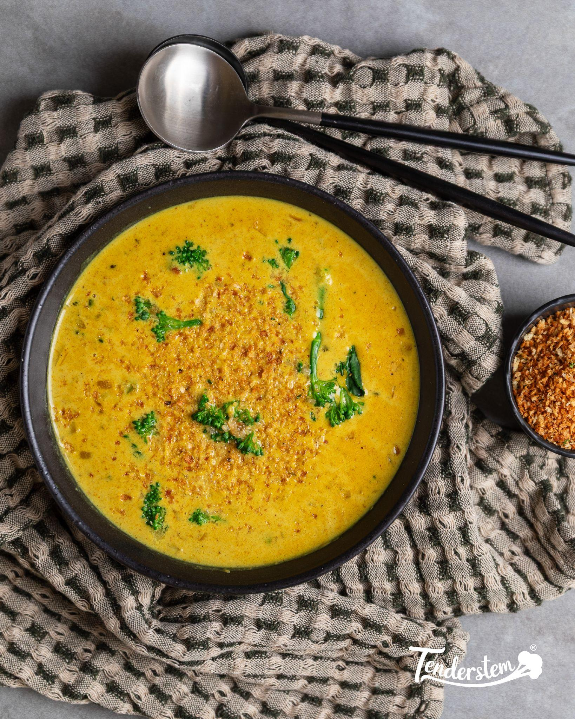
Ingredients

500g Tenderstem® broccoli
3 Tbsp olive oil
1 large onion, chopped
2 cloves garlic, minced
2 Tbsp fresh ginger, minced
4 cups vegetable stock
1 Tbsp curry powder
1 Tbsp red curry paste
1 tsp coriander powder
1 tsp turmeric powder
½ tsp cumin
1 can coconut cream

Method

- Heat the oil in your soup pot.
- Add the onions and sauté until golden.
- Stir in the garlic and ginger and sauté for another minute or two.
- Add the Tenderstem® broccoli and vegetable stock.
- Bring to a boil, then lower the heat to a simmer.
- Stir in the curry powder, curry paste, coriander, turmeric, and cumin.
- Place the lid on the soup and let it simmer for about 20 minutes.
- Remove from heat.
- Using a stick blender, blend the mixture (leaving nice chunks of Tenderstem® broccoli).
- Pour in the coconut cream and reheat the soup.
- Serve in bowls, garnished with coriander and crusty bread.
____________________________________________________________________________

Tenderstem®, mushroom, & garlic butter baby potato tray bake
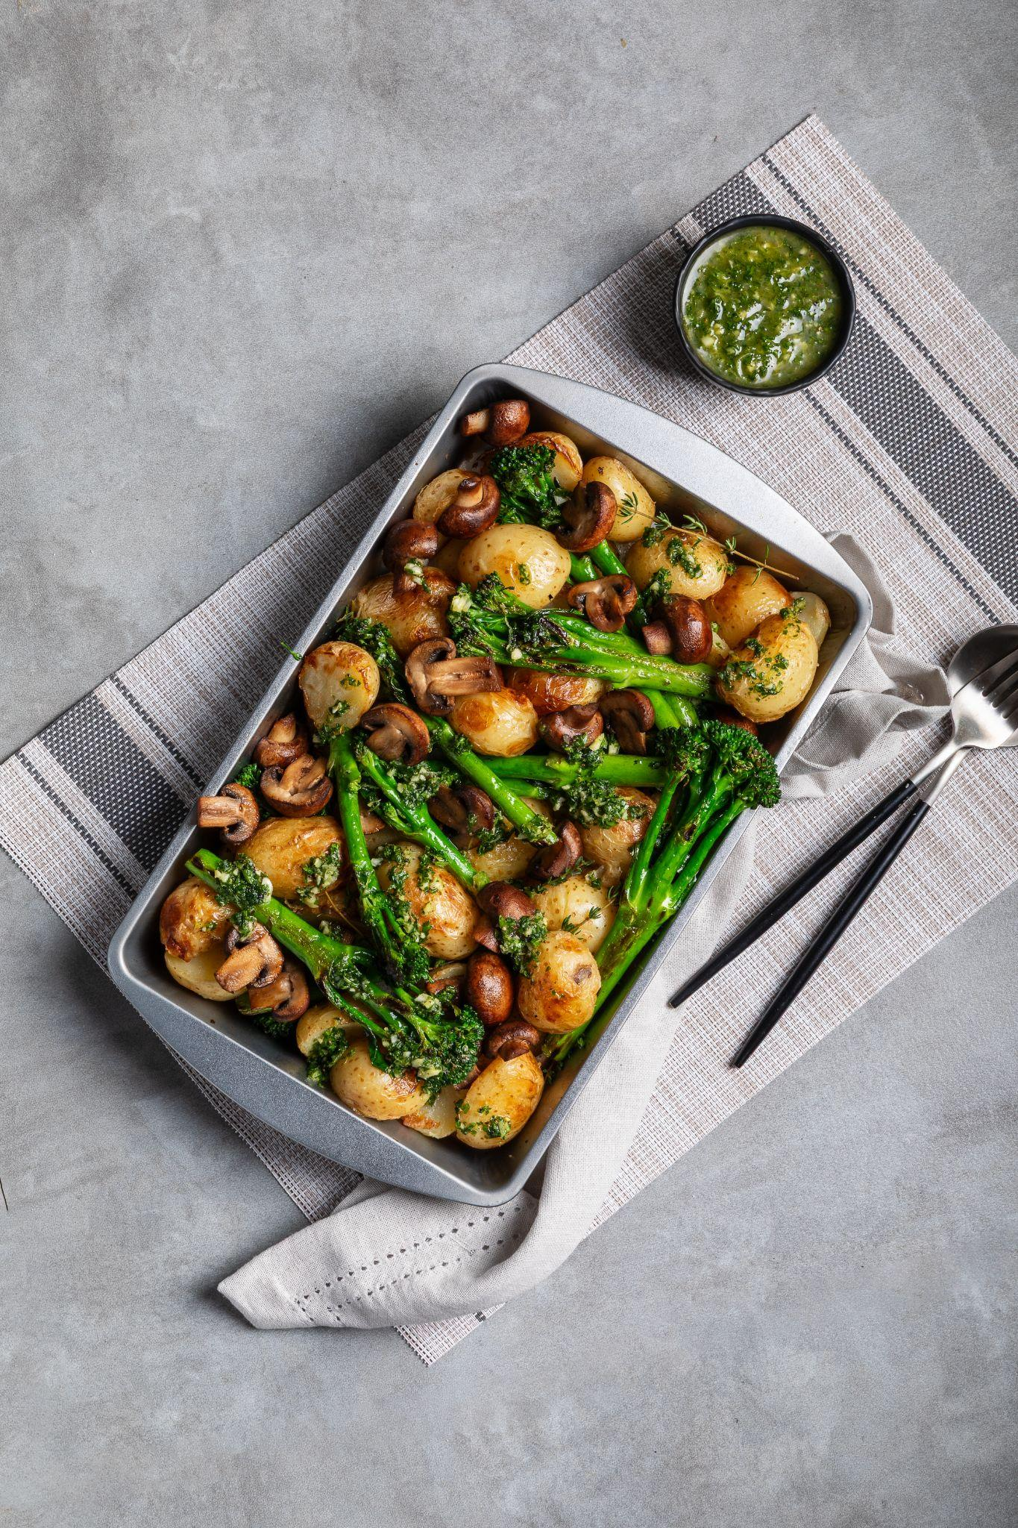
Ingredients

1kg baby potatoes
125g butter, melted
30ml olive oil
2 cloves garlic, finely chopped/grated
Rind of a small lemon, finely grated
A small handful of fresh parsley, finely chopped (save half for garnish)
Salt & pepper
250g portabellini mushrooms
300g Tenderstem® broccoli
Olive oil, for drizzling

Method

- Preheat oven to 220℃
- Place the potatoes in a large pot and cover with salted water.
- Bring to a boil and cook until tender. Drain and set aside.
- Make the garlic butter drizzle: mix the butter, oil, garlic, lemon rind, and parsley in a medium bowl, and season with salt & pepper. Set aside.
- Arrange the potatoes in a large oven tray, then use the back of a spoon to gently smash them.
- Add the mushrooms and Tenderstem® broccoli, then drizzle with the butter mixture and season with salt & pepper.
- Bake for 15 minutes or until the potatoes are golden brown.
- Scatter with parsley and serve at once.

